SQL

ADVANCE CONCEPTS

EXERCISE-1: RANKING AND WINDOW FUNCTIONS

USING ROW_NUMBER()

SELECT *

FROM (

SELECT

ProductID,

ProductName,

Category,

Price,

ROW_NUMBER() OVER (PARTITION BY Category ORDER BY Price DESC) AS RowNum

FROM Products

) AS Ranked

WHERE RowNum <= 3;

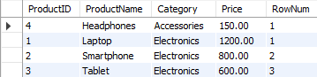

USING RANK()

SELECT *

FROM (

SELECT

ProductID,

ProductName,

Category,

Price,

RANK() OVER (PARTITION BY Category ORDER BY Price DESC) AS RankNum

FROM Products

) AS Ranked

WHERE RankNum <= 3;

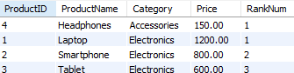

USING DENSE_RANK()

SELECT *

FROM (

SELECT

ProductID,

ProductName,

Category,

Price,

DENSE_RANK() OVER (PARTITION BY Category ORDER BY Price DESC) AS DenseRankNum

FROM Products

) AS Ranked

WHERE DenseRankNum <= 3;

